Multiple-choice section

|  |  |  |  |  |  |  |  |  |
| --- | --- | --- | --- | --- | --- | --- | --- | --- |
| Question | 1 | 2 | 3 | 4 | 5 | 6 | 7 | 8 |
| Answer | A | D | D | C | D | B | C | B |

Question 1 [2.3]

A

Let *x* be the third side of the triangle.

*x*2 = 112 – 72

= 121 – 49

= 72

*x* = 

Question 2 [2.1]

D

*z*2 = *k*2 + *t*2

therefore, *z*2 – *k*2 = *t*2

Question 3 [2.5]

D

*c*2 = 142 + 482

*c*2 = 2500

*c* = 

*c* = 50

Question 4 [2.2]

C

*c* 2 = 9.122 + 16.562

*c* 2 = 357.408

*c* = 

*c* = 18.91 (2 d.p.)

Question 5 [2.4]

D

*c* 2 = 2.32 + 1.62

*c* 2 = 7.85

*c* = 

*c* = 2.8 m (1 d.p.)

Question 6 [2.2]

B

The sloping side is the hypotenuse of a right-angled triangle with shorter sides of (6 – 2) and (4 – 2).  
Let its length be *x*.

*x*2 = 42 + 22

*x*2 = 20

*x* =  ≈ 4.47 (2 d.p.)

The perimeter is 4 + 6 + 2 + 2 + 4.47 = 18.47.

Question 7 [2.4]

C

Mia walks back along the hypotenuse of the right-angled triangle with shorter sides of 200 m and 300 m.

distance walked = = 360.56 m (2 d.p.)

distance run = 200 m + 300 m = 500 m

difference = 500 m – 360.56 m = 139.44 m

Question 8 [2.5]

B

Pythagoras’ theorem can be used if triples are not known.  
Triangle 1: From the triple (20, 21, 29) the missing length is 21. The area is 210.  
Triangle 2: The area is 330.  
Triangle 3: From the triple (12, 35, 37) the missing length is 35. The area is 210.  
Triangle 4: From the triple (15, 20, 25) the missing length is 15. The area is 150.  
Triangles 1 and 3 both have areas of 210.

Multiple-choice total marks: 8

Short answer section

Question 9 1 mark [2.1, 2.2]

Many square roots are irrational numbers. Written as rounded decimals, they are rational approximations. To write an exact value, it must be written in surd form.

Question 10 4 marks [2.1]

Δ*ABC*

82 + 8.42 = 134.56

11.62 = 134.56

82 + 8.42 = 11.62

Pythagoras’ theorem holds.

Therefore, Δ*ABC* does have a right angle.

Δ*DEF*

5.72 + 62 = 68.49

8.32 = 68.89

5.72 + 62 ≠ 8.32

Pythagoras’ theorem does not hold.

Therefore, Δ*DEF* does not have a right angle.

Question 11 2 marks [2.2]

*z*2 = 13.962 + 9.522

*z*2 = 285.512

*z* = 

*z* = 16.8971 (4 d.p.)

*k*2 = 16.89712 + 7.922

*k* 2 = 348.238

*k* = 

*k* = 18.7 (1 d.p.)

Question 12 2 marks [2.2]

*w*2 = 92 + 82

*w*2 = 81 + 64

*w*2 = 145

*w* = 

Question 13 3 marks [2.2]

*z*2 = 16.062 + 8.922

*z* 2 = 337.49

*z* = 

*z* = 18.3709

*b*2 = 8.922 + 12.462

*b* 2 = 234.818

*b* = 

*b* = 15.3238

*z* – *b* = 18.3709 – 15.3238

The difference between the lengths of the hypotenuses is 3.05 (2 d.p.).

Question 14 3 marks [2.3]

*t*2 + (3*t*)2 = 2002

*t*2 + 9*t* 2 = 40 000

10*t* 2 = 40 000

*t*2 = 4000

*t* = 

*t* = 63.25 (2 d.p.)

Question 15 2 marks [2.3]

Let *x* be the unknown shorter side.

*x*2 + ()2 = 212

*x* 2 + 80 = 441

*x* 2 = 441 – 80

*x* 2 = 361

*x* = 

*x* = 19

Question 16 2 marks [2.3]

*u*2 = 11.772 – 8.42

*u*2 = 67.9729

*u* = 

*u* = 8.24 (2 d.p.)

Question 17 3 marks [2.4]

The plank between the trestles, the ground and the lower part of the trestle legs form an isosceles trapezium.

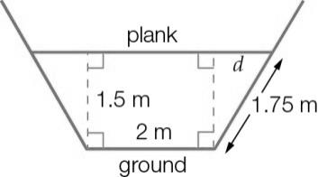

Let the distance along the plank from the step to the point directly above the foot of the trestle be *d* m.

The step is halfway up the 3.5 m trestle, so the distance along the trestle from the ground to the step is 1.75 m.

*d*2 = 1.752 – 1.52

*d*2 = 0.8125

*d* = 

The length of plank between the two trestles is (2 + 2*d*) m ≈ 3.80 m (2 d.p.).

Question 18 3 marks [2.4]

(a) Let the height of the mould be *h* cm.*h*2 = 132 – 82

*h*2 = 105

*h* = 

(b) The volume of the mould is the product of the area of the triangle and the width of the mould.

*V* =  × 8 × × 4

*V* = 164 cm3 (to nearest whole number)

Question 19 2 marks [2.2]

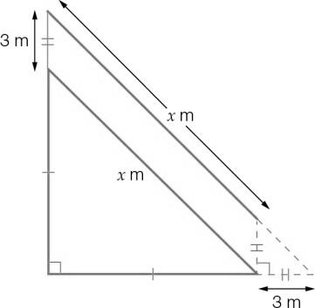

This shows that the extra length needed is the hypotenuse of a right-angled triangle with shorter sides of 3 m.  
 m

The hypotenuse of the larger triangle is  m (or  m) longer.

Question 20 2 marks [2.5]

**(a)** 332 + 562 = *v*2

*v*2 = 4225

*v* = 

*v* = 65

**(b)** *j*2 = 852 – 362

*j*2 = 5929

*j* = 

*j* = 77

Question 21 2 marks [2.5]

**(a)** 202 + 482 = 2704

522 = 2704

202 + 482 = 522

Pythagoras’ theorem holds. {20, 48, 52} is a Pythagorean triple.

**(b)** 632 + 722 = 9153

972 = 9409

632 + 722 ≠ 972

Pythagoras’ theorem does not hold. {63, 72, 97} is not a Pythagorean triple.

Question 22 2 marks [2.5]

A Pythagorean triple that gives a perimeter of 40 cm is needed.

8 cm, 15 cm and 17 cm is one such triple.

Perimeter:

8 + 15 + 17 = 40 cm

Pythagoras’ theorem:

82 + 152 = 289

172 = 289

82 + 152 = 172

Pythagoras’ theorem holds.

Therefore, 8 cm, 15 cm and 17 cm are possible side lengths.

Short answer total marks: 33

Extended answer section

Question 23 5 marks [2.1, 2.5]

(a)

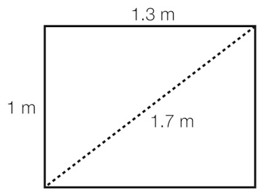

(b) 12 + 1.32 = 2.69

1.72 = 2.89

12 + 1.32 ≠ 1.72. Pythagoras’ theorem does not hold. Therefore, the room is not square.

(c) By reducing the width, length and diagonal to 0.9 m, 1.2 m and 1.5, Jasper would have lengths which are multiples of the (3, 4, 5) Pythagorean triple.

If this is too small, he could multiply the numbers by 0.35 instead of 0.3, giving 1.05 m, 1.4 m and 1.75 m.

Question 24 9 marks [2.2, 2.4]

(a)

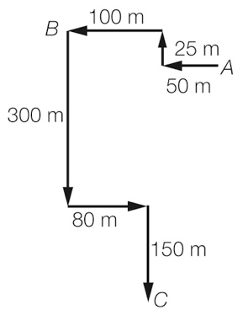

**(b)** Houda: 100 + 25 + 50 = 175 m

Jose: 300 + 80 + 150 = 530 m

Jose walked 355 m further (530 m – 175 m = 355 m).

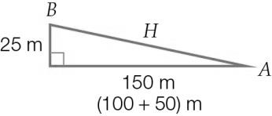

(c) *H*2 = 1502 + 252

H2 = 23 125

H = 

H = 152.07 m (2 d.p.)

(d)

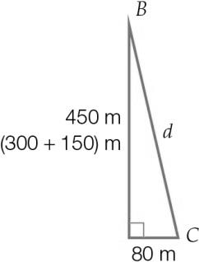

*d*2 = 4502 + 802

*d*2 = 208 900

*d* = 

*d* = 457.06 m (2 d.p.)

(e) 457.06 m – 152.07 m = 304.99 m

The ice-cream shop is 304.99 m closer.

Question 25 9 marks [2.3, 2.4]

(a) *m*2 = 1.42 – 1.12

*m*2 = 0.75

*m* = 

*m* = 0.866 m

**(b)** *n*=1.1 + 0.2 + 0.2 = 1.5 m

**(c)** Large rectangle:

*A* = *L* × *W*

*A* = 1.5 × (0.866 + 0.2 + 0.2)

*A* = 1.899 m2

Small rectangle:

*A* = *L* × *W*

*A* = 1.1 × 0.866

*A* = 0.9526 m2

Area required

1.899 – 0.9526 = 0.9464 m2

Thus, area = 0.95 m2

**(d)** 1.1 × 0.95 = 1.045 m2 bought

$11.20 × 1.045 = $11.70

cost = $11.70

Extended answer total marks: 23

TOTAL test marks: 64